Theme 2: The Family is the Cornerstone of Raising and Educating
2- Empowering family influence on societal, national growth,and renaissance

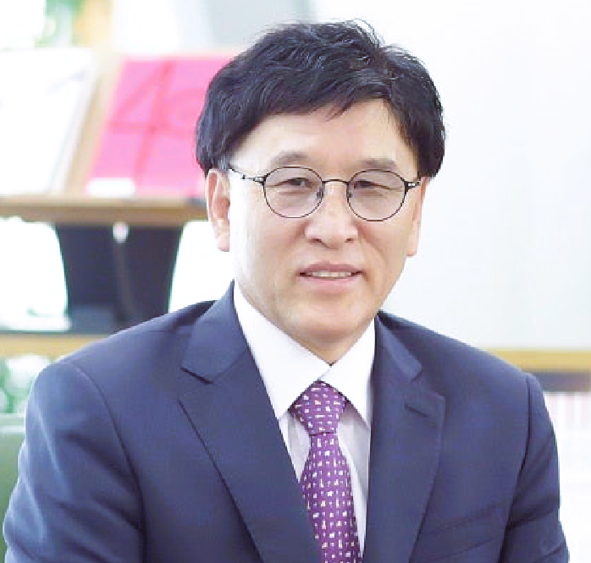

Professor DR.Musa Kim Jong Do
E-mail: musakim@naver.com
Cell Phone: +82-10-8708-5681
Professor in Arabic Linguistics
Center for Middle East & Islamic Studies
Korea University in Seoul, Korea
Musa Kim Jong-do is currently a Distinguished professor and Director of Center for Middle East & Islamic Studies at Korea University since 2023. In 1992, he received his Ph.D from the Omdurman Islamic University in Sudan for his research on ‘Noun phrases in the Qur'an’. He has been leading and introducing research in unexplored areas in Korea in addition to his main field of linguistic research; for example, the basic foundations of Islam, Shari'ah, and Arabic practical law. In 2015, he translated Ko Eun's "South and North" and won the Egyptian Publication Corporation's award for poetry in foreign literature in 2015 with his co-translator. He has taught Arabic and Islam at about 15 Universities, and is opening currently 7 courses at Korea University. He has served as the president of the KAMES(Korea Association of Middle East Studies), KAALAL(Korea Association of Arabic Language & Arabic Literature), KAHIS(Korea Association of Halal Industry Studies) and his major works include the Kim Jong-do Arabic Series, 1-3' and more than 40 books and 70 articles, including 'A Study on Qur'anic Ethics'.

